Rice Grain Quality Determination Using Probabilistic Neural Networks

Authors Name/s per 1st Affiliation (Author)

line 1 (of Affiliation): dept. name of organization

line 2-name of organization, acronyms acceptable

line 3-City, Country

line 4-e-mail address if desired

Authors Name/s per 2nd Affiliation (Author)

line 1 (of Affiliation): dept. name of organization

line 2-name of organization, acronyms acceptable

line 3-City, Country

line 4-e-mail address if desir

ABSTRACT

Food remains an eternal need for our survival. More so, rice is the staple diet of most south Asian countries. Rice quality is often degraded when impurities like broken or damaged seeds are present. It’s a herculean task to determine the quality of grains using computer vision. We have come up with a system, in this paper, that ascertains the class of rice grains. Rice grain images are acquired, pre-processed and Probabilistic Neural Network (PNN) algorithm is applied on the images. The classification has been done in accordance with chalkiness, HoG and GLCM features. The system outputs good, average or bag quality rice grains using PNN classifier. Our proposed model can be implemented in agriculture-based industries for grain evaluation purposes which will simplify the grading of rice grains for the consumers.

Keywords— Computer Vision, Rice Grain Quality, Probabilistic Neural Networks

# INTRODUCTION

Rice is a source of vital minerals and vitamins and is nutritionally highly enriching and healthy. Rice, mostly is consumed after it is boiled, or in some cases it is milled into flour and consumed. It is a staple meal for 80 per cent of the world's population [2] .It is energy-rich and nutrient-rich, and has a low glycaemia score. India stands amongst the top two global producers of rice. Agriculturists conduct the study of grain size, gradation, and their quality attributes manually. Such approaches are vulnerable to many issues, such as being extremely subjective, affected by human factors and working environments leading to incoherent performance. Also, the rate of salvage clean-up and recovery is low. A significant element in the agriculture industry is the harmless assessment of the food products to grade the product quality.

Non-destructive food product grading determines the quality, taking into consideration the form, color, internal deformations, etc. without actually breaking the food products into its constituent parts. It is measured using advanced computer vision techniques without disturbing the internal somatic constituent particles of these items. Rapid developments in digital image processing hardware and software has stimulated hardcore research on the development of cutting-edge image processing systems for evaluating the class of various food items. Progression in computer technology is an invaluable contribution in the food processing domain such as ranking, sorting, and quality inspection. The accuracy of the system can be improved by employing features of texture. Accuracies in classification are very strong when specific features of the checked varieties are used. There are many benefits of artificial neural networks and probabilistic neural networks over fuzzy classifiers and statistical classifiers. The obvious and a viable option for the classification of food products is neural network-based machine learning algorithms.

# STATE OF ART

Siddagangappa et al. have developed an automated system using the Probabilistic Neural Network to identify and assess the quality of three Indian rice varieties into three grades. The researchers have come up with a pattern which uses geometric and colour-based characteristics as classification attributes. Rice is measured by grain kernel size and presence of impurities. Six characteristics only, i.e. Average RGB colours and 3 geometric elements, achieve reasonable accuracy in the ranking. Average identification success rate is 98 percent, and average grade determination is 90 percent and rice grading success rate 92 percent [1]

Zahida Praveen et al, proposed an image processing algorithm to ascertain the quality of rice on the basis of length, width, area, chalkiness and color. Color features are calculated using RGB and HSV color models. Features are analysed on the histogram to determine the quality of the rice grains. Proposed algorithm consists of several steps: preprocessing, smoothing, object measurement, edge detection, histogram, classification result. Results are based on area, length, width and chalkiness [2].

Another method used to grade rice using image processing were proposed by Wanputri et al., Previous researchers have applied various approaches to classifying rice grain images by employing particular characteristics such as rice form, length, chalkiness, colour and grain deformations. The authors have taken a total of 285 images and obtained an accuracy of 46.6% [4].

Harpreet Singh et al, proposed an image processing technique for grain classification. A semi-automated machine is introduced for food quality analysis. Parameters for grading are Aspect Ratio, weight Texture, Chalkiness, Whiteness, Length and Width. The techniques which is used to extract these features are Kernels separation by Sieving method, Grain analysis by various image processing methods, seed count, image acquisition-based analysis of rice grains, inspection of kernel quality by automatic/semi-automatic grain analysis [5].

Deepika Sharma et al, proposed a neural network classifier based technique to ascertain the grade of wheat and rice samples. Rice grain images were captured by employing a high-resolution camera. Images underwent pre-processing and segmentation was carried out to separate all constituent grains. Morphological features of the grain were extricated and used for analysis and classification. The processing and the consequent classification have been done by using a Neural Network classifier. Grains are graded into good, medium and bad quality [6].

# PROBABILISTIC NEURAL NETWORKS: A DISCUSSION

Donald Specht’s pioneering research on PNN has had a profound impact on classic neural network classification-based applications. PNN is a highly complex structure and a feed-forward neural network. It contains input, pattern, summation and output layers as depicted in the adjacent picture. Albeit PNN being a highly complex network, it has only one smoothing training parameter. Hence there is not much of an effort required to train the database. Also, it is interesting to note that PNN works very efficiently even when the database consists of a small sample of data.

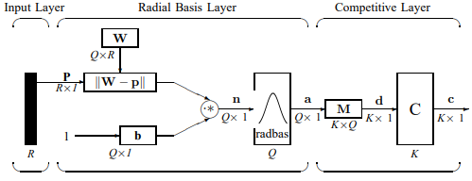

**Figure 1: PNN network for R=5, Q=1500, K=3**

The structure of the PNN for the proposed system is depicted in the above Figure 1. We have adopted all the symbols and notations as specified in the original research by Donald F Specht[27]. MATLAB neural network toolbox too uses the same interpretation in the inbuilt function newpnn() [28].

1. **Input Layer**: In Figure 5, **p** represents the input vector, represented as the vertical bar. The dimension of the input layer is R x 1. We have considered R to be 5.
2. **Radial Basis Layer**: In this layer, a computation of the dot product of the weight vector of each row of weight matrix W and the the given input vector **p** is done. [29]. Q x R is the dimension of **W**. The vector distance between the ith row of W and the input vector p gives the ith element of the distance vector ||W− p||. The dimension of this is Q x 1. The symbol “-” represents the distance between the vectors. Now, the calculated ||W-p|| is fused with the bias vector **b** as shown in Figure 1 in a component-by-component form which is depicted as “*” in the figure. The outcome of the calculation is shown as **n** = ||**W − p**|| · ∗**p**.
3. **Competitive Layer**: The concept of bias is absent in the Competitive layer, unlike the Radial basis layer. Here in this layer, a product of the output of radial basis function, a and the weight matrix M is considered. This results in another output vector named d. This layer produces 1 correlating to the highest component of the vector d and produces zeroes to all the others. Competitive function results in another output depicted as c in the Figure 1. All values equating to 1 in c represents the quantity of rice grains which the proposed system classifies rightly. It can be used as the index to look for the scientific name of this plant. The output vector’s dimension (K) is 3 as we have considered 3 types of rice grains.

# METHODOLOGY

The proposed system could be used in the food and agriculture industries extensively for grading purposes. Figure 2 depicts the flow of events in our system. The initiation of the process is done with image acquisition. The proposed system considers rice grain image samples which are captured by a high-resolution digital camera and then fed as an input to the image processing unit. MATLAB R2018a is employed to process the data under consideration. The classification result is then showcased on the MATLAB console in the form of bad or average or good quality rice grains based on the test input. We have considered a total of 1500 images and 500 images each of bad, average and good quality rice grain images for training. The images are pre-processed using standard pre-processing techniques. Features which include Chalkiness, Histogram of Oriented Gradients and Gray Level Co-occurrence Matrix are considered. Geometric features are not considered due to the nature of the database images. The features extracted are stored in feature vectors. All the images are then trained. Sample rice grain images acquired for testing purposes are then tested for their accuracies which are labelled as Good, Average and Bad quality rice grains. The percentage of chalkiness is determined using standard techniques. The flow of the system is depicted as below.

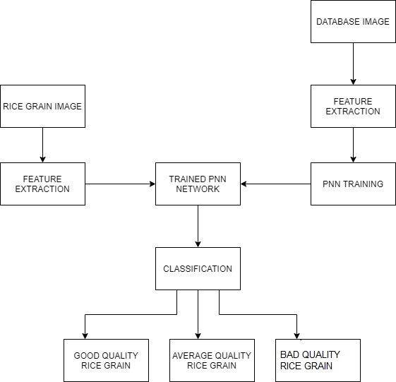

**Figure 2: System block diagram**

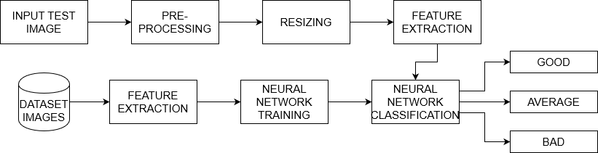

**Figure 3: Proposed Architecture**

1. **Image Acquisition**: Grain images are taken with the help of a camera. Preferably a high-resolution camera may be used so that the accuracy does not vary.
2. **Pre-processing**: Various pre-processing techniques are applied to increase the classification accuracy. The techniques include filtering, thinning, background elimination etc.,
3. **Image binarization**: Grayscale image is taken and binarized image containing only contrasts of black and white is given as output.
4. **Image Dataset**: Dataset image is taken into consideration
5. **Feature extraction**: A Variety of features are taken into consideration. These features are:
   1. Chalkiness
   2. Histogram of Oriented Gradients
   3. Gray Level Co-occurrence Matrix

PNN Training and classification: PNN is applied to train all the images. Further, the features which were extracted earlier are employed to classify the rice grain images into three classes, viz., bad, average and good quality rice grains.

# RESULTS

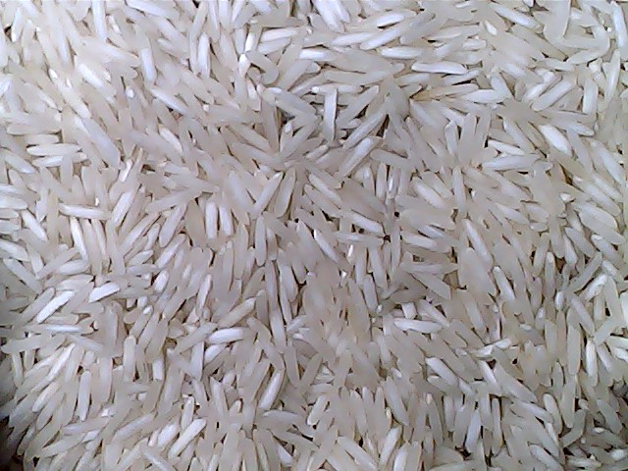

**Figure 4: Good quality grain image taken from Dataset**

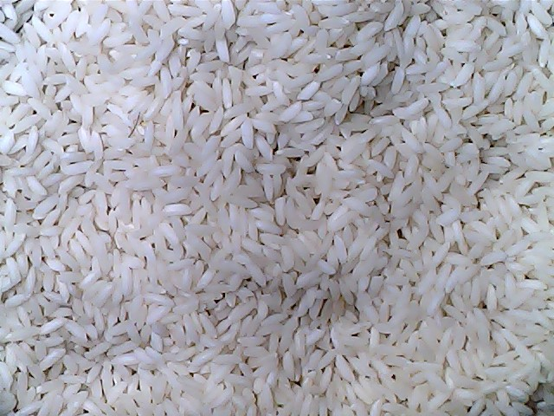

**Figure 5: Average quality grain image taken from Dataset**

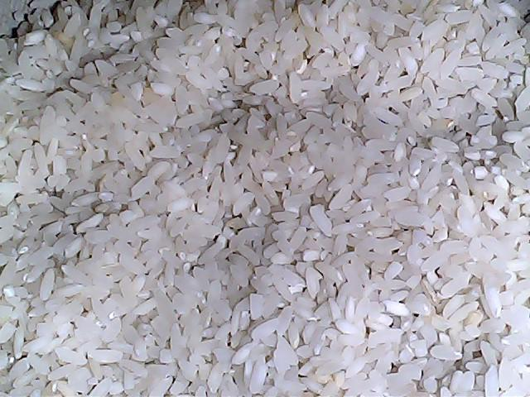

**Figure 6: Bad quality grain image taken from Dataset**

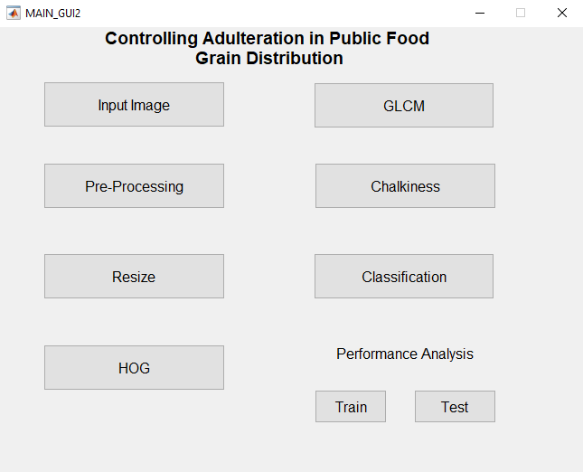

**Figure 7: GUI of the proposed model**

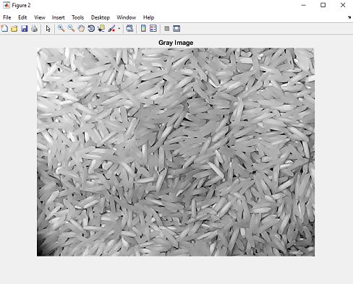

**Figure 8: Grayscale Image**



**Figure 9: Percentage of Chalkiness**



**Figure 8: Classification Result**

The results have been tabulated as below:

**TABLE I. RECOGNITION RATES FOR VARIOUS TYPES OF GRAINS**

|  |  |
| --- | --- |
| **Type of rice grain** | **Recognition Rate** |
| Good | 100% |
| Average | 100% |
| Bad | 100% |

**TABLE II. RESULTS BASED ON VARIOUS METRICS**

|  |  |
| --- | --- |
| **Metric** | **Value** |
| Accuracy (Train) | 100% |
| Accuracy (Test) | 97.89% |
| Precision | 96.83% |
| Recall | 97.33% |

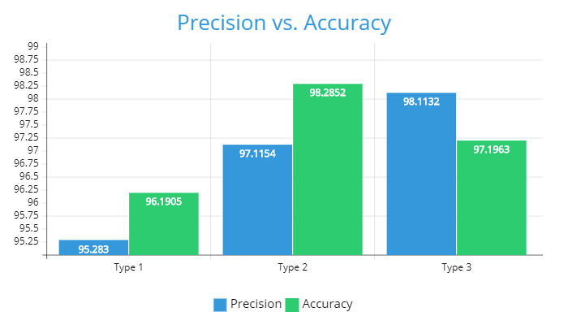

**Figure 10: Precision vs. Accuracy for each grain type**

# CONCLUSION AND FUTURE WORK

The proposed system classifies rice grains based on chalkiness, Histogram of Oriented Gradients and Gray level Co-occurrence Matrix features into good, average and bad classes using Probabilistic Neural Networks.

**TABLE III. ACCURACY COMPARISON**

|  |  |
| --- | --- |
| **Scheme** | **Accuracy** |
| Deep CNN [7] | 95.5 |
| LVQ neural network [8] | 70.3 |
| BPNN [9] | 80.5 |
| PNN [10] | 93 |
| PNN [11] | 87.5 |
| Region Proposals based CNN [12] | 67.25 |
| Spatio-Spectral Deep CNN [13] | 93.27 |
| Proposed in [14] | 80.64 |
| Our Approach | 97.89 |

The comparison reveals that the proposed algorithm outperforms other methods. Routinely, PNN is known to outpace other algorithms in a machine vision application. The proposed system is completely automated and proves to be of a great use to the agriculture-based industries. We have found out that the results for rice grain grading using probabilistic neural networks to be highly lucrative and obtained high levels of accuracy.

We have acquired images without any advanced technology enabled camera in research conditions. Acquiring of images could have been done under different lighting conditions. The proposed method could be extended to a wide variety of other species of rice grains. Further, our method can be extended to other food grains. The major research extension would be to optimize the neural network to increase the rate of accuracy

##### REFERENCES

[1] Siddagangappa M.R. and Kulkarni A.P.A “Classification and Quality Analysis of Food Grains” IOSR Journal of Computer Engineering. p. 16.

[2] Neelam Jyoti Gupta. 2015 “Identification and Classification of Rice Varieties Using Neural Network By Computer Vision”. International Journal of Advanced Research in Computer Science and Software Engineering. 5(4): 992-997.

[3] Vidya Patil, V. S. Malemath. 2015. “Quality Analysis and Grading Of Rice Grain Images” International Journal of Innovative Research in Computer and Communication Engineering. 3(6): 5672-5678.

[4] Harpreet Singh, Chandan Singh Rawat, “Image Processing Techniques for Analysing Food Grains”, International Conference on Computing Methodologies Communication (ICCMC) 978-1-4244-7164-5 IEEE 2019.

[5] Deepika Sharma, Sharad D Sawant, “Grain Quality Detection by using Image Processing for public distribution” International Conference on Intelligent Computing and Control Systems 978-1-5386-2745-7 IEEE 2017

[6] Rubi Kambo, Amit Yerpude “Classification of Basmati Rice Grain Variety using Image Processing and Principal Component Analysis,” VOL.11 number 2 May 2014.

[7] P. Lin & X. L. Li & Y. M. Chen & Y. He, “A Deep Convolutional Neural Network Architecture for Boosting Image Discrimination Accuracy of Rice Species” Springer Science+Business Media, LLC, part of Springer Nature 2018

[8] Lilik Sumaryanti , Aina Musdholifah , Sri Hartati, “Digital Image Based Identification of Rice Variety Using Image Processing and Neural Network”, TELKOMNIKA Indonesian Journal of Electrical Engineering Vol. 16, No. 1, October 2015, pp. 182 ~ 190

[9] L.A.I.Pabamalie, H.L.Premaratne, “A Grain Quality Classification System” IEEE, 2010

[10] Arun Jana et al., “Classification of Aromatic and Non-Aromatic Rice using Electronic Nose and Artificial Neural Network” [2011 IEEE Recent Advances in Intelligent Computational Systems](https://ieeexplore.ieee.org/xpl/conhome/6059528/proceeding)

[11] Lili Wu, Chao Yuan, Aiying Lin, and Baozhou Zheng, “Identification of Early Moldy Rice Samples by PCA and PNN” ICCIP 2012, Part I, CCIS 288, pp. 506–514, 2012. © Springer-Verlag Berlin Heidelberg 2012

[12] Kittinun Aukkapinyo, Suchakree Sawangwong, Parintorn Pooyoi, Worapan Kusakunniran, “Localization and Classification of Rice-grain Images Using Region Proposals-based Convolutional Neural Network” ©  Institute of Automation, Chinese Academy of Sciences and Springer-Verlag GmbH Germany, part of Springer Nature 2019

[13] Itthi Chatnuntawech, Kittipong Tantisantisom, Paisan Khanchaitit, Thitikorn Boonkoon , Berkin Bilgic , Ekapol Chuangsuwanich, “Rice Classification Using Spatio-Spectral Deep Convolutional Neural Network” [arXiv:1805.11491v3](https://arxiv.org/abs/1805.11491v3)

[14] Shu-fang QIN, Chang-hua LIU and Shen-ao HUANG, “Identification Rice Varieties Based on K-means Clustering Algorithm and BP Neural Network” 2017 2nd International Conference on Advanced Materials Science and Environment Engineering (AMSEE 2017) ISBN: 978-1-60595-475-2.